FAST School of Computing, National University of Computer and Emerging Sciences, Islamabad

Data Analysis and Visualization

Lab Manual 10

Lab Learning Outcomes:

By the end of this lab, students will be able to:
- Use D3.js to load, parse and prepare time series data (for example with d3.csv, d3.timeParse, d3.autoType, d3.rollup and d3.cumsum), converting date strings into real dates and aggregating daily rows into monthly summaries.
- Design and implement line, area and multi-line charts in D3.js using d3.scaleTime, d3.scaleLinear, d3.line, d3.area and d3.axisBottom, and explain how a time scale places each observation at its true date.
- Design and implement stacked area, band and heatmap visualizations in D3.js using d3.stack, d3.scaleBand and d3.scaleSequential, encoding composition, spread and seasonal patterns through area, shading and colour.
- Design and implement interactive, honest time series charts in D3.js using d3.bisector, d3.brushX or d3.zoom, with a moving average and a broken line at missing data, to reveal trend, seasonality, outliers and gaps.
- Analyze and justify the choice of chart for a time series question (trend, composition, spread, comparison, pattern), and evaluate the trade-offs between a line chart, a bar chart and a heatmap in terms of accuracy of perception, clarity and suitability for the data.

Submission Requirements:

- Submit the project folder with the HTML file, the JavaScript file (if the code is kept separate), on both GCR and GitHub. Submission is incomplete without both.
- GitHub: push into your section repo, inside the week’s folder, in your own subfolder named RollNumber_Section (e.g., 24F1234_5A). The subfolder must contain the .html file, any .js file, and the cleaned dataset, kept in the same folder structure the code expects (for example dataset/penguins.csv), so the chart loads without editing any paths.
- GCR: use the file naming convention RollNumber_Section_LabXX (e.g., 24F1234_5A_Lab06.html). If the lab has more than one file, upload a single .zip with that name.
- Test the page through a local server (such as VS Code Live Server) before submitting. The chart and all visuals must appear when the page is opened, with no errors in the Console other than harmless ones like the missing favicon.
- Keep your GitHub subfolders updated weekly. A complete, organized profile is checked at the Capstone stage (Week 15–16).
- complete, organized profile is checked at the Capstone stage (Week 15–16).

Time series data is a sequence of measurements recorded in time order. Every record has two parts:
Timestamp + Value(s), e.g. 2026-11-03, 28.4°C
Time is not just another column. It is the axis the whole dataset is organized around. Shuffle the rows of a normal table and nothing is lost. Shuffle a time series and the data is destroyed, because the order is the information.
Four things we look for in any time series:
Component | Meaning | Example
Trend | Long-term rise or fall | Fuel prices rising over years
Seasonality | Pattern that repeats at fixed intervals | Electricity demand peaks every summer
Noise | Random short-term fluctuation | Day-to-day price wiggles
Anomalies | Sudden unusual spikes or drops | Flood-day river level, a market crash

2. Why are we covering it in this lab?

- Most real data is time-based. Sensors, finance, health, weather, and web analytics all produce data over time.
- It introduces new D3 skills you haven’t used yet: d3.timeParse, d3.scaleTime, d3.line, d3.bisector, and time axes.
- It trains analytical thinking. The goal moves from “draw the data” to “find the story in the data”: what changed, when, and why.
3. Why it matters for current real-world problems
Decisions today depend on understanding change over time:
- Climate and environment: temperature, rainfall, and glacier or river-level trends. Pakistan’s floods and heatwaves are time-series problems, since early warning depends on spotting abnormal patterns early.
- Air quality: tracking AQI hour by hour shows when smog episodes begin, peak, and end, which is what lets authorities issue warnings.
- Public health: disease cases per day show whether an outbreak is growing or slowing, and whether an intervention worked.
- Economy: inflation, exchange rates, fuel prices, and stock indices. People want to know when prices changed and how fast.
- Energy: electricity demand and load-shedding patterns over the day and year help with planning supply.
- Technology: server traffic, app usage, and IoT sensor streams, where anomaly detection prevents failures.

In all of these, the questions are about time: Is it rising? When did it start? Is it repeating? Is this normal? A visualization has to answer those questions at a glance.

4. Why ordinary charts don’t work well for this data
The charts you already know (bar, pie, scatter) were designed for data where order doesn’t matter. They fail on time series for specific reasons.
Pie chart
- It shows parts of a whole at a single moment, with no concept of time or sequence.
Bar chart
- It treats each x value as a separate category. With 365 daily values you get 365 thin bars and a cluttered picture.
- Bars emphasize individual values instead of the continuous flow between them, so the trend is hard to see.
Scatter plot
- Points are shown independently with nothing linking one moment to the next. The eye can’t follow the progression.
Common problems all of them share
Problem | Why it hurts
No continuity | Time is continuous, but these charts show it as separate chunks
Too many points | Thousands of readings cause overplotting and clutter
Uneven or missing intervals | A category axis spaces dates equally even when there are gaps, which distorts the picture
Multiple time scales | Daily noise, monthly seasonality, and yearly trend are all in one dataset, and static charts can’t show all of them
Hidden patterns | Trend and seasonality need smoothing, such as a moving average, to become visible
No way to explore | You can’t zoom into a spike or compare two periods without interaction

Example1:
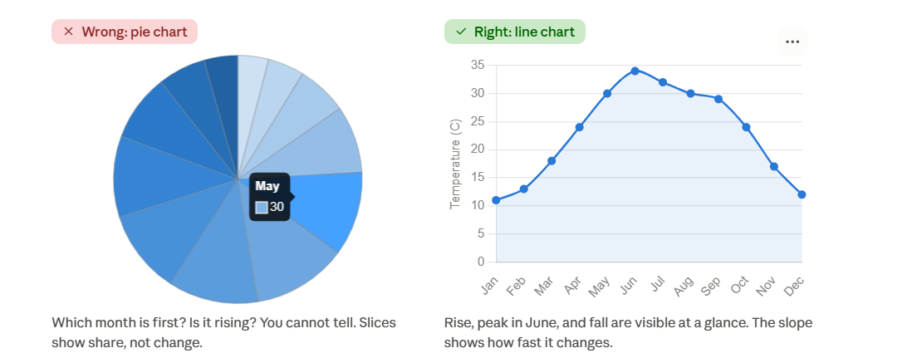

Example 2:

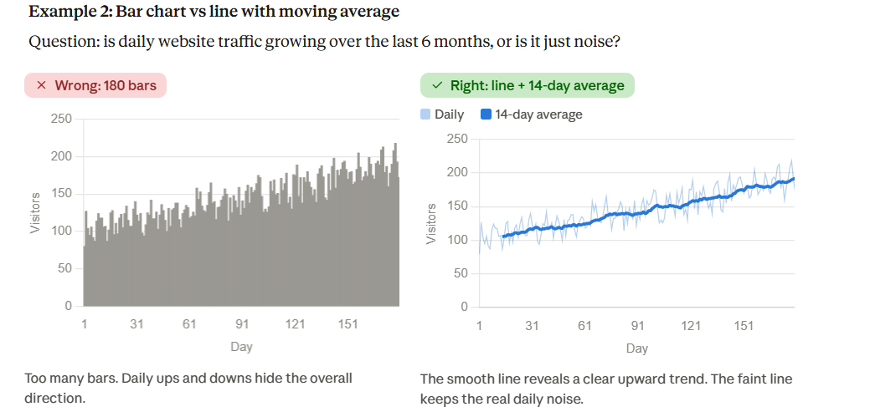

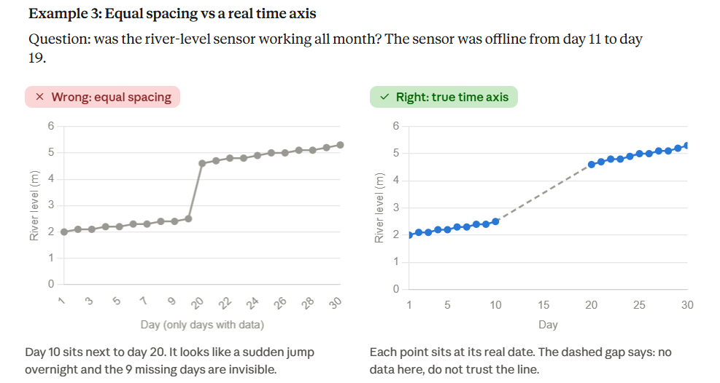

There are about 8 common chart types for time series data. Each one answers a different kind of question, so the question decides the chart.

# | The question you are asking | Chart | Example
1 | How does one value change over time? | Line chart | PM2.5 every day for a year
2 | How big is the change, and how much total is there? | Area chart | Cumulative rainfall, daily cases
3 | How do several series compare over time? | Multi-line chart | City vs suburb PM2.5
4 | How do parts add up to a whole over time? | Stacked area chart | Electricity by source (hydro, gas, solar) per month
5 | Is there a repeating pattern (day of week, month, hour)? | Heatmap / calendar heatmap | Pollution by hour of day × day of week
6 | What is the range or spread in each period? | Candlestick or band chart | Stock open/high/low/close, daily min-max temperature
7 | What is the trend once noise is removed? | Line + moving average | Daily traffic with a 7-day average
8 | Which period of a long series should I look at closely? | Zoomable / brushable line chart | Pick one month out of 10 years

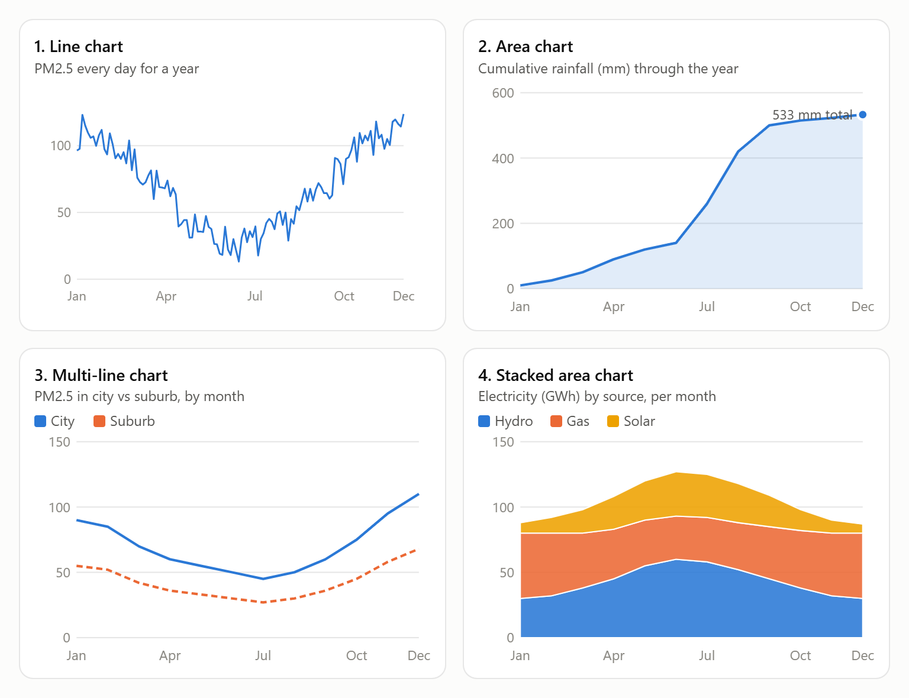
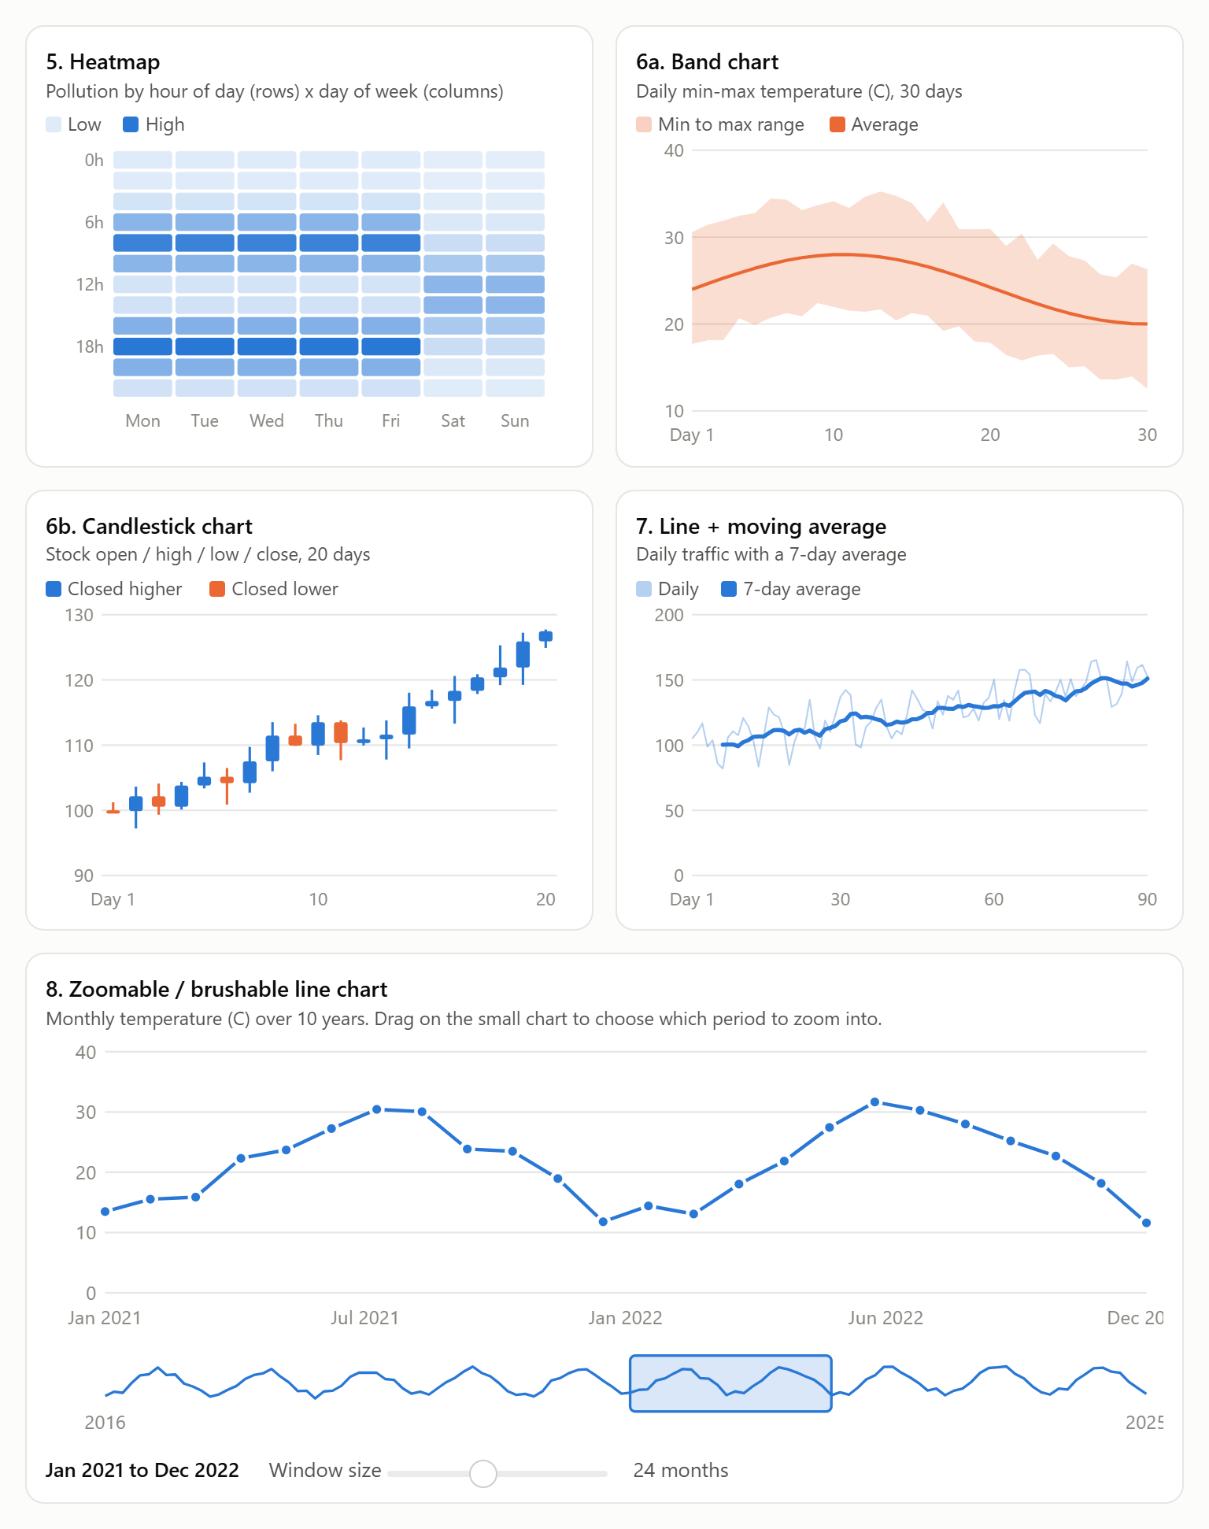

The pipeline: from date text to a drawn line

"2026-10-30" -> Date object -> pixel position -> drawn on screen
(text) (parse) (scaleTime) (axis, line, dots)

Steps | Job | D3 function that does it | What it does
2. Parse | Convert date text into real dates | d3.timeParse("%Y-%m-%d") | Turns "2026-10-30" into a JavaScript Date
3. Find gaps | Count days between two dates | d3.timeDay.count(a, b) | Tells you how many calendar days are between neighbours
4. Average | Calculate the moving average | d3.mean | Averages a few values
6. Scales | Convert dates to x pixels | d3.scaleTime | Maps a date to a position on screen
6. Scales | Convert values to y pixels | d3.scaleLinear | Maps a temperature to a position on screen
6. Scales | Find the first and last date | d3.extent | Returns [min, max] so the axis covers the data
9. Axes | Draw the time axis with labels | d3.axisBottom(x) | Draws the ticks and labels along the bottom
9. Axes | Format the labels | d3.timeFormat("%d %b") | Turns a Date back into text like 26 Oct
10. Line | Turn the data into a path | d3.line() | Builds the SVG path from your x and y functions
12. Hover | Find the nearest sample to the mouse | d3.bisector and x.invert | Converts mouse pixels to a date, then finds the closest sample

Lab Tasks:

Scenario
You are a junior data analyst at the City Environment Office. Next week the Director presents to the Smog Action Committee, which will decide when to start school-hour restrictions and where to spend a limited budget on new sensors. She has asked you for clear charts showing how air pollution in the capital behaved through 2025.
The office measures PM2.5 (fine particles in the air, in µg/m³) once a day at two stations, one in the city centre and one in a suburb. It also records the daily average temperature. PM2.5 is the pollutant most linked to smog, so the Director wants to know when it gets dangerous, how fast it changes, and whether the data can be trusted.
Yesterday a committee member looked at a pie chart of monthly averages and said, “So pollution is the same all year?” The Director was not happy. Your job is to replace that pie chart with charts that answer questions about time. Each question below needs a different kind of chart.

Your data
One file, air_quality_2025.csv, with one row per day for 2025.
Column | Meaning | Unit
date | Day of the reading | date
pm25_city | Daily average PM2.5, city centre | µg/m³
pm25_suburb | Daily average PM2.5, suburb | µg/m³
temp_c | Daily average temperature | °C

This is a practice dataset. The patterns are realistic, but the numbers are not official measurements. The WHO 24-hour guideline for PM2.5 is 15 µg/m³, and its interim target 1 is 75 µg/m³. You will use both as reference lines.

Task 1:
- Count the rows and find the first and last dates.
- Compare the row count with the number of days in 2025. Write down what you notice.
Task 2:
Question: how did PM2.5 in the city centre change through the year?
- Plot the daily city PM2.5 as a line against time.
- Add dashed reference lines at 15 and 75 µg/m³, each labelled.
- Mark the two highest days with a point and a label showing the date and value.
- Count the days above 15 and above 75, and show both numbers under the title.
Task 3:
Question: how quickly did unhealthy days (above 75 µg/m³) build up during the year?
- For each day, work out the running total of days so far that were above 75.
- Plot the running total as a filled area. The last value must match your count from Task 2.
Task 4:
Question: does the suburb behave like the city centre?
- Plot the city and suburb values as two lines in different colours on the same axes, with a legend.
Task 5:
Question: in each month, how are the days split between pollution levels?
- Give each day a level: Low (35 or below), Moderate (36 to 75), High (76 to 150), Severe (above 150).
- Count the days per level in each month, and stack the four levels so that each month’s stack adds up to its number of days.
- Use light-to-dark colours for the levels, with a legend.
- Some months will be shorter than others. Find out why.
Task 6:
Question: is pollution tied to the day of the week, the month, or both?
- Work out the average city PM2.5 for every month and day-of-week combination.
- Draw a grid with months on one side and weekdays on the other, and colour each cell by its average, with a colour legend.
Task 7:
Question: how wide is the gap between the best and worst day in each month?
- For each month, find the minimum, maximum and mean.
- Shade the area between the minimum and maximum, and draw the monthly mean as a line through it.
Task 8:
Question: what is the trend once daily noise is removed, and was the sensor working all year?
- Calculate a 7-day moving average (each day averaged with the previous six).
- Draw the daily values as a thin, faint line and the 7-day average as a thick, dark line.
- Find the gap in the dates. Break the line at the gap instead of joining the two sides, and do not average across it.
- Shade the gap, label it “No data: sensor offline”, and add a note with the number of missing days.
Task 9:
Question: can the Director pick any period and look at it closely?
- Add a small overview of the whole year under the main line chart. Selecting a range on it should zoom the main chart to those dates.
- Add a reset button that shows the full year again.

Questions for the Director

Answer each in demo, point to a specific chart, and include a number, month or date.

Seasonality : Which months are worst and which are best? Roughly how many times higher is the worst month than the best?
Anomalies : Name the two highest days. Are they part of the seasonal pattern or isolated spikes? What real-world events could cause them?
Guideline : How many days were above 15 µg/m³, and how many above 75 µg/m³? What share of the recorded days is each?
Build-up : In which months do unhealthy days build up fastest, and in which months does the curve go flat?
Comparison: Does the suburb follow the same pattern as the city centre? Where do they differ most?
Composition : Which months have Severe days, and which month has the most Low days? Why are some months shorter than others?
Pattern : Is there a day-of-week pattern, or is the pattern mostly by month? What does that suggest about the cause of the pollution?
Spread : In which month is the gap between the best and worst day the widest? Why does a monthly average hide this?
Trend and data quality : Is there a long-term rise or fall, or only a seasonal cycle? How many days are missing, and why is an unbroken line over the gap misleading?
Zoom : Zoom into the month with the widest spread. What can you see there that you could not see in the full-year chart?
Chart choice: The committee member used a pie chart of monthly averages. List two things it could not tell the Director that your charts do.
Recommendation: If the committee can restrict outdoor school activities for only two months, which two would you pick? Support your answer with evidence from at least two different charts.

